McWilliam, Robert (from Linked In and ANU Alumni Notes 2015)
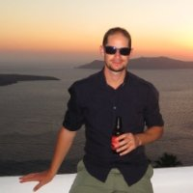

Education

University of Salzburg Masters of Science, Geographic Information Science and Cartography 2011 – 2013

The Australian National University Bachelor's of Science with Honors, Forestry 1998 – 2003

Experience

Senior Manager TFT August 2009 – Crassier, Switzerland

Senior Technical Advisor WWF Laos 2008 –2009 Xekong Province, Lao PDR

National Forest Inventory Coordinator Forestry Department, Fiji Islands 2005 –2008 Suva, Fiji Islands

Operations Forester ACT Forests 2003 –2005 Canberra

Research in conjunction with Forest and Wood Products Research and Development Corporation Australian National University 2002 –2003 Canberra Area

Short Term Consultant Tropical Forest Trust 2001 –2002 East Kalimantan Province, Indonesia

ANU Alumni Notes April 2015
1 April 2015
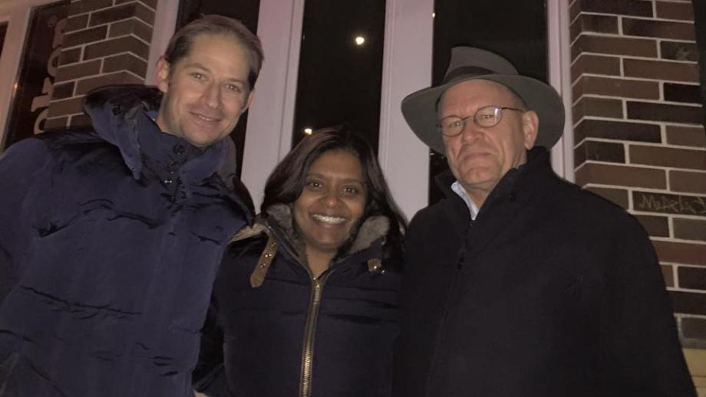
Rob McWIlliam, Radhika Murti and Peter Kanowski
Radhika Murti (BSc (Forestry) (Hons) '03 & Robert McWilliam BSc (Forestry) (Hons) '03 bumped into Master of University House, and Professor of Forestry in the Fenner School of Environment & Society Peter Kanowski (BSc (Forestry) (Hons) '82) at their local pub in Gland, Switzerland (pictured). Radhika and Robert met at ANU and are now married. Robert works for The Forest Trust and is working with small and large businesses around the world to establish and implement strong procurement policies that eliminate deforestation and respect people and the environment. Radhika is working in Disaster Risk Reduction for the International Union for Conservation of Nature. Radhika recently delivered a speech at the UN World Conference on Disaster Risk Reduction in Japan, and did a TED talk on disaster risk reduction.

